8 WEATHERING

Weathering is a set of physical, chemical and biochemical processes of destruction and transformation of rocks and constituent minerals in the subsurface of the Earth's crust. This is due to various factors – the effect of temperature fluctuations, exposure of air, water and living organisms to rocks, etc. If rocks are on the surface for a long time, the weathering crust forms as a result of their transformation. The destruction and redistribution of material are on the Earth’s surface: rocks, formed in bowels of the Earth, on the surface collapse and form a new group of genetic rocks, for example at destruction of granite may be formed sand. Weathering leads to destruction of even the hardest rocks by mechanical (physical) or chemical ways.
There are these types of weathering: physical and chemical.
Physical weathering is mechanical destruction of rocks during extreme temperature fluctuations. In the desert there is peeling or desquamation (lat. "desquamare" – removing scales), when from the smooth rock surface with significant temperature fluctuations scales or thick plate, parallel to the surface are peeled. This process particularly well can be seen in separate blocks, boulders.
Processes of physical weathering lead to mechanical destruction of rocks – their grinding and turning the source rocks in the weathering zone without changing the composition to the gravel, gruss, sand or dust.
The main factors leading to the destruction of rocks in the weathering zone are: temperature fluctuations caused by changes in solar activity; the impact of water when it freezes in the cracks and pores of rocks, the crystallization of salts; wedge-shaped effect of a developing root system; vital activity of burrowing animals.
In the hot desert areas mechanical action on the rocks and disintegration are also carried out by growth of salt crystals formed from water, that fall within the capillary cracks as solutions. Different gravitational processes develop in addition to weathering: avalanches, rockfall, debris, landslides. Accumulated at the base of the slopes and foothills products of gravitational processes (landslides, avalanches) are a kind of genetic type of continental deposits, called colluvium (Lat. colluvio – accumulation).
Intensive physical (mechanical) weathering takes a place in areas of severe climatic conditions (in polar and subpolar countries) with the presence of permafrost, caused by its excessive surface moisture. Under these conditions, weathering is mainly due to the wedging action of freezing water in cracks and other physical and mechanical processes associated with ice formation. Disjoining impact on the rocks is also provided by the root system of growing trees. Mechanical work is also produced by a variety of burrowing animals. In conclusion, we should say that the purely physical weathering leads to the fragmentation of rocks, to mechanical destruction, without changing the mineral and chemical composition.
Along with the physical weathering in areas with washing type of humidification mode also processes of chemical change forming new minerals occur.
Chemical weathering is lead by these processes.
Oxidation especially intensively occurs in minerals containing iron. On some deposits of sulphide and other iron ores the “бурожелезняковые hat”, consisting of oxidized and hydrated weathering products are observed. Air and water in ionized form destroy the ferrous silicates and convert ferrous iron into ferric.
Hydration. Hydration of minerals occurs under the influence of water, i.е. fixation of water molecules on the surface of individual sections of the crystal structure of the mineral. Hydrated kind is also a hydrogoethite. Process of hydration is observed in more complex minerals - silicates.
Dissolution. Many compounds are characterized by a certain degree of solubility. Their dissolution goes by the action of water, flowing over the surface of rocks and leaking through cracks and pores to depth. Accelerate the dissolution processes are caused by high concentration of hydrogen ions and content in the water of О₂, СО₂ and organic acids. Chlorides possess the best solubility among chemical compounds – halite (table salt), sylvite, etc. In second place – sulfates: anhydrite and gypsum. In the third place there are carbonates: limestones and dolomites. During the dissolution of said species in a number of locations there is the formation of various karsts on surface and in depth.
Hydrolysis. During the weathering of silicates and aluminosilicates hydrolysis has importance, wherein the structure of crystalline minerals is destroyed due to water and ions dissolved in it, and is replaced by a new substantially different from the original and inherent in the newly formed supergene minerals. Process of hydrolysis phasically proceeds with sequential appearance of several minerals. Thus, during supergene transformation of feldspars hydromicas occur, which are then converted into minerals of kaolinite or halloysite.
In temperate climate zones kaolinite is stable enough and as a result of accumulation in the weathering kaolin deposits are formed. But in a humid tropical climate there may be a further decomposition of kaolinite to free oxides and hydroxides.
Thus, oxides and hydroxides of aluminum are formed, which are an integral part of the aluminum ore – bauxite.
While weathering of basic rocks and especially volcanic tuffs among forming supergene clay minerals along with hydromicas montmorillonites, and belonging to the group of high-alumina mineral beidellite, are widespread. While weathering of ultramafic rocks (ultrabasites) nontronites or ferruginous montmorillonite are formed. With the significant atmospheric moisture nontronite is destroyed, in this case there are formed oxides and hydroxides of iron (phenomenon of обохривания of nontronites) and aluminum.
As a result of single and complex interrelated physical, chemical and hemobiogenous processes of destruction of rocks different products of weathering are produced: eluvium, diluvium and colluvium (fig. 6.1).

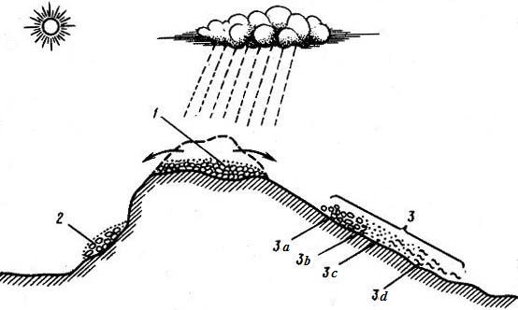
Fig.6.1. Scheme of formation of elluvium (1), colluvium (2) and deluvium (3):
3a – ballast; 3b – gravel; 3c – sandy loam; 3d – loam

The totality of the destruction products, both residual, and displaced, is called weathering crust. The most favorable conditions for the formation of strong weathering crusts are relatively leveled relief of surface of the source rocks in combination with hot, humid climate and an abundance of organic matter. Process of formation of weathering crust is complex and multi-stage.
Meaning of weathering processes
Processes of weathering perform the conversion of upper horizons of earth crust. During weathering crushing and chemical decomposition of solid and strong igneous, metamorphic and sedimentary rocks and turning those into loose, easily destructible formation occur.
Increasing the degree of fracturing and porosity in the process of physical weathering, changes in mineral composition, structure and texture of the parent rocks by chemical weathering lead to a change in the physical and mechanical properties of rocks, located in the weathering zone. Weathered rocks characterized by high porosity and, consequently, increased water absorption. Their strength values are significantly lower than in fresh rocks. Therefore weathered rocks are poorly stable in the outcrops of underground mine workings, on the slopes of quarries and natural outcrops. They are environment of origin of landslides, avalanches, floods and landslides. However, weathered rock is easier to develop.
In practice, considering the importance of the physical and mechanical, and especially the strength properties of rocks, there is applied index - the degree of weathering or weathering factor (к_{w}). The degree of weathering is understood by the attitude of weathered rock density to the density of unweathered. This indicator shows the decrease in the density and strength properties of rocks under the influence of physical and chemical weathering.
The correct assessment of the properties of weathered rock gets an importance at designing quarries, choosing the slope and road pits escarpments construction, construction pits and pit walls, in calculating reserves of conditional blocks of natural stone building materials (marble, granite, quartzite and etc.), while an installing the capacity of removal zone of weathering of rocks and depth of the foundations for the construction of engineering structures and etc.
Weathering processes are associated with the formation and modification of various mineral deposits. Loose products of physical weathering – rubble, boulders, gravel, sand and partly of clay, are valuable building materials used in various industries. In the process of eluvium formation many resistant minerals are released of primary rocks, forming eluvial placer deposits of gold, platinum, cassiterite, ilmenite, diamond and etc.
As a result of chemical weathering there are deposits of kaolin, bauxite, nickel, iron and manganese ores.
All exogenous or denudation agents (wind, surface water, underground water, glaciers, seas) perform geological work under the general scheme, which can be divided into three phases. The first stage is the destruction of bedrock, exposed on the surface or under the influence of exogenous agents. In the second phase under the influence of the same agents there are demolition and transportation of products of destruction, i.e. these masses move to the sedimentation basin. Quantitatively, the living force of the transport agent is evaluated by the formula F=mv²/2, where m – mass of agent; v – its speed. At the third stage, there is the accumulation of deferred destruction products, i.e. their sedimentation, for example, in the form of sand and clay deposits of deserts or sediment in rivers, lakes or seas.

6.2. Geological activity of wind (eolian processes)

Wind occurs in the troposphere. Troposphere is lower layer of atmosphere (thickness up to 10 km at high latitudes, up to 18 km at the equator), makes up 4/5 of all mass of atmosphere, it contains almost all water vapor, clouds are formed, temperature decreases by altitude. The main causes of air movement are solar energy, the Earth's rotation, land and sea distribution, the nature of the relief, air friction on the surface of the Earth. Under the influence of these factors on the Earth there is an uneven distribution of atmospheric pressure and air currents generated by them, directed from high pressure to lower pressure. Uneven distribution of continents and oceans causes air circulation (monsoons – winds, blowing in summer from colder ocean towards the land, and vice versa in winter).
Winds, hurricanes, typhoons, tornadoes originate in the troposphere. Rocks, baring on the surface, are destroyed both due to wind forces and using their portable sand and dust. Fractions, transported by wind, hit the surface of the exposed rocks, as a result of such hits, repating many times, soft areas of bedrock are destroyed and recess, trough, furrow, strokes and etc. are formed on the surface.
Grinding out by wind on rocks of various indentations, and also hatching and polish of crags are called corrasion (Lat. corrasio – grinding). Forms of corrosion manifestation are diverse. Expansion of cracks occurring in the bedrock by weathering, leads to the creation of unique forms of relief, as eolian city, described by V.А. Obruchev in Zhongar, or known as Krasnoyarsk pillars.
In direct contact of air jets with loose or slightly cemented rocks there is comes blowing and carryover of material. Blowing and carryover of solid particles of bedrocks by wind are called deflation (Lat. deflatio – blowing). Speed of deflation is determined by wind power, mode of occurrence, strength of rocks and etc. Deflation occurs especially intensively where weathering processes are well developed.
In the mountain valleys as a result of blowing of outcropping strata, folded by less strong rocks, there are formed various kinds of depressions, on the plains deflation leads to blowing of the upper loose layer. In arid areas as a result of deflation there is blowing of salt layer from the marsh surface.
Results of destructive operation are: eolian mushrooms, eolian niches, blowing boilers, eolian cave.

Wind makes a great constructive work, creating a kind of positive and negative forms of relief. Accumulation of material transported by the wind begins depending on the terrain, the nature of vegetation covering it and the dominant wind regime. The resulting sand-clay rocks are called loess – eolian deposits. Particularly intense eolian sediment formation occurs in areas with arid climate, with sharp daily and seasonal temperature fluctuations. Such areas with extremely dry climates, where evaporation from the exposed surface is much higher than atmospheric precipitation, are called the desert.
Accumulative forms of relief are eolian barchans and dunes. Barchan is crescent sandy hill with a long and gently sloping windward and leeward short steep slope, passing in the wind elongated horns (fig. 6.2). The height reaches 10–20 m (sometimes 200–300 m), and speed of movement in the direction of the prevailing winds 200 m/year. Dune is crescent-shaped sandy hill, resembling a dune, but unlike it in the dunes horns are directed towards the wind. Dunes are formed on wet basis; therefore they are spread along the banks of major rivers and seas.
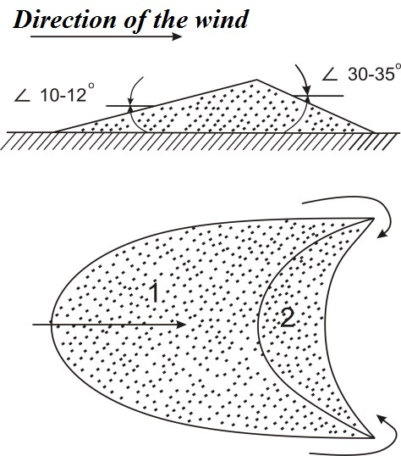

Fig. 6.2. Barkhan: а) in section; б) view from above

Types of deserts: sandy, clayey, stony. Products of eolian sediments are: loess, sand. Characteristics of eolian sediments: the predominance of fine-grained particle size of less than 1 mm, a small amount of particles of 1 to 10 mm; dominated by terrigenous material, unclear layering.
Loess deserts are formed in the areas of accumulation of very small dust particles carried by wind. The accumulation of such particles (more than 50% with size of 0.05–0.1 mm) leads to forming of loose and porous rock of pale yellow color – loess. Loess covers vast areas of the globe. Thus, zone of loess deposits along the foothills of the Alatau stretches from east to west nearly 1,500 km. They are clearly visible on the south side of Almaty as a step landforms and characteristic pale yellow color deposits. High-rise TV tower is built on the loess sediments of Koktobe.

Control questions
- Exogenous geological processes, their types and source of energy.
- Weathering and factors, affecting on its intensity.
- Physical weathering, its kinds and results.
- Chemical weathering, its kinds and results.
- Products of weathering.
- Menaing of weathering processes.
- Denudation, its meaning and agents.
- Accumulation and its meaning.
- What is wind and what are its kinds?
- What are corrosion and deflation?
- What are loess and loess deserts?
- What are barchans and dunes, how are they formed and what is the difference between them?

